Germany_Total_Wind_Energy

Swathi

26/06/2022

rm(list=ls())  
library(dplyr)

## Warning: package 'dplyr' was built under R version 4.1.3

##   
## Attaching package: 'dplyr'

## The following objects are masked from 'package:stats':  
##   
## filter, lag

## The following objects are masked from 'package:base':  
##   
## intersect, setdiff, setequal, union

library(ggplot2)

## Warning: package 'ggplot2' was built under R version 4.1.3

set.seed(200)  
germany_totalwind<-read.csv("Germany Total Wind Energy.csv")  
head(germany_totalwind,4)

## ï..Year Wind Onshore.wind.energy Offshore.wind.energy  
## 1 2000 6095 6095 0  
## 2 2001 8754 8754 0  
## 3 2002 12001 12001 0  
## 4 2003 14381 14381 0

colnames(germany_totalwind)

## [1] "ï..Year" "Wind" "Onshore.wind.energy"   
## [4] "Offshore.wind.energy"

germany_totalwind <- germany_totalwind %>%  
 rename(Year = ï..Year,  
 Onshore_wind_energy = Onshore.wind.energy,  
 Offshore_wind_energy = Offshore.wind.energy)

head(germany_totalwind,4)

## Year Wind Onshore_wind_energy Offshore_wind_energy  
## 1 2000 6095 6095 0  
## 2 2001 8754 8754 0  
## 3 2002 12001 12001 0  
## 4 2003 14381 14381 0

linear_model1<-lm(Year~Wind,data=germany_totalwind)  
summary(linear_model1)

##   
## Call:  
## lm(formula = Year ~ Wind, data = germany_totalwind)  
##   
## Residuals:  
## Min 1Q Median 3Q Max   
## -1.3988 -1.1733 -0.2524 0.9140 2.2540   
##   
## Coefficients:  
## Estimate Std. Error t value Pr(>|t|)   
## (Intercept) 1.999e+03 5.629e-01 3551.58 < 2e-16 ***  
## Wind 3.428e-04 1.503e-05 22.81 8.67e-16 ***  
## ---  
## Signif. codes: 0 '***' 0.001 '**' 0.01 '*' 0.05 '.' 0.1 ' ' 1  
##   
## Residual standard error: 1.28 on 20 degrees of freedom  
## Multiple R-squared: 0.963, Adjusted R-squared: 0.9611   
## F-statistic: 520.2 on 1 and 20 DF, p-value: 8.671e-16

p<-ggplot(germany_totalwind) + # Create ggplot2 plot  
 geom_line(aes(x=Year,y=Wind,color="purple"))+labs(title="Germany_TotalAvailableWindEnergy")  
p

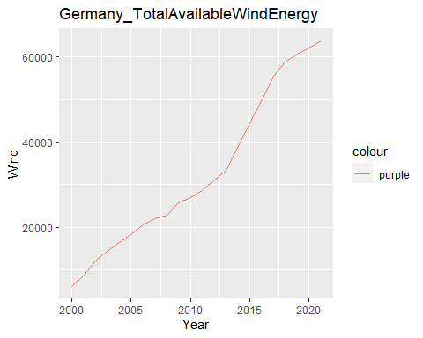

p + scale_color_manual(name="colour",   
 labels = c("MW"  
 ),   
 values = c(  
 "purple"="purple"))

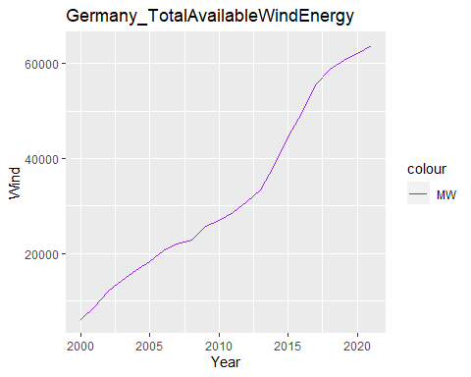

##not a good graph hence converting variables to logs

log_germany_totalwind<-germany_totalwind  
log_germany_totalwind$log_Wind<-log(germany_totalwind$Wind+1)

reg_germany_total_wind<-lm(Year~log_Wind,data=log_germany_totalwind)  
summary(reg_germany_total_wind)

##   
## Call:  
## lm(formula = Year ~ log_Wind, data = log_germany_totalwind)  
##   
## Residuals:  
## Min 1Q Median 3Q Max   
## -1.7316 -0.8903 -0.2200 0.4716 3.9322   
##   
## Coefficients:  
## Estimate Std. Error t value Pr(>|t|)   
## (Intercept) 1912.1643 4.8439 394.76 < 2e-16 ***  
## log_Wind 9.6270 0.4733 20.34 7.82e-15 ***  
## ---  
## Signif. codes: 0 '***' 0.001 '**' 0.01 '*' 0.05 '.' 0.1 ' ' 1  
##   
## Residual standard error: 1.429 on 20 degrees of freedom  
## Multiple R-squared: 0.9539, Adjusted R-squared: 0.9516   
## F-statistic: 413.8 on 1 and 20 DF, p-value: 7.817e-15

plot(reg_germany_total_wind)

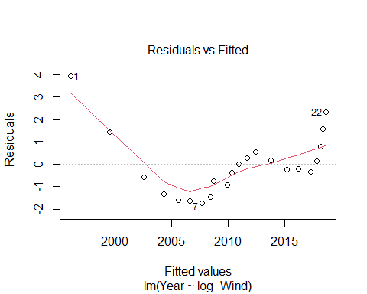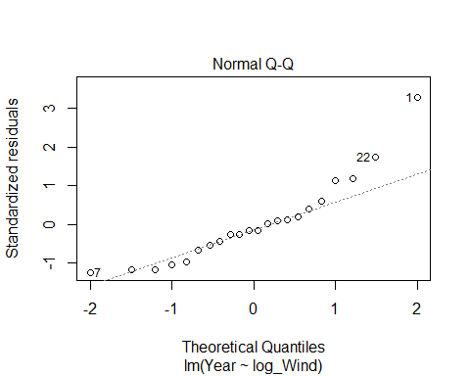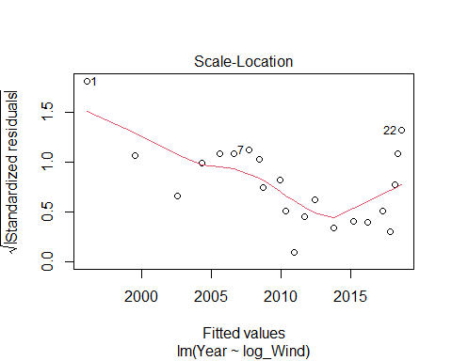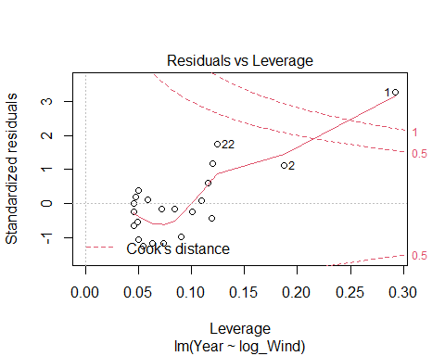

p<-ggplot(log_germany_totalwind) + # Create ggplot2 plot  
 geom_line(aes(x=Year,y=log_Wind,color="purple"))+labs(title="Germany_TotalAvailableWindEnergy")  
p

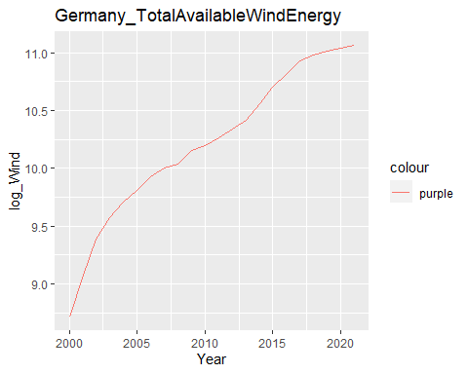

p + scale_color_manual(name="colour",   
 labels = c("MW"  
 ),   
 values = c(  
 "purple"="purple"))

